Policy Name | Research Misconduct and Retraction Policy
Proposed By | Director ORIC
Reviewed By | Registrar and Pro-VC
Approved By | ORIC Steering Committee
Effective From | 01-07-2026
Next Review Date | 30-06-2028
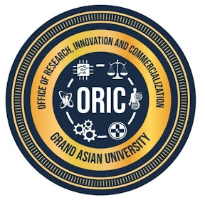
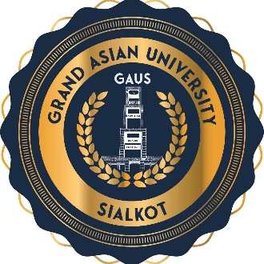
- Purpose
Grand Asian University is committed to upholding the highest standards of research integrity, academic honesty, and professional responsibility. This policy establishes a comprehensive framework for preventing, reporting, investigating, and addressing research misconduct while ensuring fairness, confidentiality, due process, and the protection of the scholarly record. The policy also provides institutional guidance for correcting published research through corrections, expressions of concern, and retractions where necessary.
- Scope
This policy applies to all research conducted under the auspices or affiliation of Islam Group and Grand Asian University, regardless of discipline, funding source, or location. It applies to faculty members, researchers, postgraduate and undergraduate students, visiting scholars, research associates, consultants, administrative staff involved in research administration, and external collaborators undertaking research on behalf of the University.
- Policy Statement
Grand Asian University adopts a zero-tolerance approach towards research misconduct while ensuring that all allegations are addressed fairly, impartially, and confidentially. The University distinguishes between deliberate misconduct, negligent research practices, and honest scientific error. While intentional misconduct shall be subject to disciplinary action, genuine errors identified and corrected in good faith shall be regarded as part of the normal process of scientific inquiry.
- Definition of Research Misconduct
Research misconduct includes, but is not limited to, fabrication of data or records, falsification or manipulation of materials or results, plagiarism in any form, misrepresentation of research findings, redundant publication without appropriate disclosure, inappropriate authorship practices, manipulation of images or datasets, concealment of conflicts of interest, unauthorized use of confidential information, misuse of research funds, violation of approved ethical protocols, destruction or concealment of research records, and obstruction of an investigation.
- Reporting Allegations
Any member of the University or external stakeholder may report suspected research misconduct to ORIC. Allegations should be made in good faith and supported by sufficient evidence. The identity of both the complainant and the respondent shall remain confidential, except where disclosure is required by law or is necessary to ensure procedural fairness.
- Formal Investigation
The Vice Chancellor shall constitute an independent committee comprising subject experts and individuals with no conflict of interest. The Committee shall examine all relevant evidence, interview concerned parties, review research records, seek expert opinion where appropriate, and provide the respondent with a reasonable opportunity to present evidence and respond to the allegations. The committee shall submit a written report containing its findings and recommendations to the Vice Chancellor for appropriate action.
- Findings and Institutional Actions
Where research misconduct is established, the University may impose corrective or disciplinary measures proportionate to the seriousness of the violation. Such actions may include formal warning, mandatory ethics training, withdrawal of research funding, suspension of research privileges, removal from supervisory responsibilities, cancellation of awards or incentives, and disciplinary proceedings under university regulations,
- Retraction of Research Publications
A publication may be recommended for retraction where credible evidence demonstrates that its findings are unreliable due to fabrication, falsification, plagiarism, duplicate publication, unauthorized use of data, unethical research practices, significant methodological flaws, authorship fraud, or any other serious breach of research integrity. Researcher may be required to return institutional publication incentives, research awards, financial benefits, and other recognition received on the basis of the affected publication. Retracted publications shall not be considered for recruitment, promotion, tenure, graduation, performance evaluation, institutional rankings, or future funding opportunities.
- Appeals
Researcher may submit a written appeal to the Vice Chancellor within thirty (30) days of receiving the decision. Appeals shall be considered only where new evidence is presented or where a significant procedural irregularity is demonstrated. The decision of the appellate authority shall be final.
- Policy Review and Amendments
This policy shall be reviewed every two years, or earlier if required, to ensure alignment with the University's strategic priorities, HEC regulations, emerging technologies, and international best practices. Amendments shall be approved by the appropriate statutory bodies of the University.
Proposed By: Approved By:

Director ORIC Vice Chancellor/ Chairman ORIC-SC
Grand Asian University Sialkot Grand Asian University Sialkot

